Image

📘 Definition
# Source: AI Source: Provided by: [Data Path: Persons Table -> ID Column: 1, Name_En Column: Motasem Essam] -> From: [ChatGPT] on [5/2/2026]
An image is a visual representation of something, such as a picture, drawing, or photograph, that can be seen by the human eye or displayed on a screen.

🖼️ Types of images
# Source: AI Source: Provided by: [Data Path: Persons Table -> ID Column: 1, Name_En Column: Motasem Essam] -> From: [ChatGPT] on [5/2/2026]
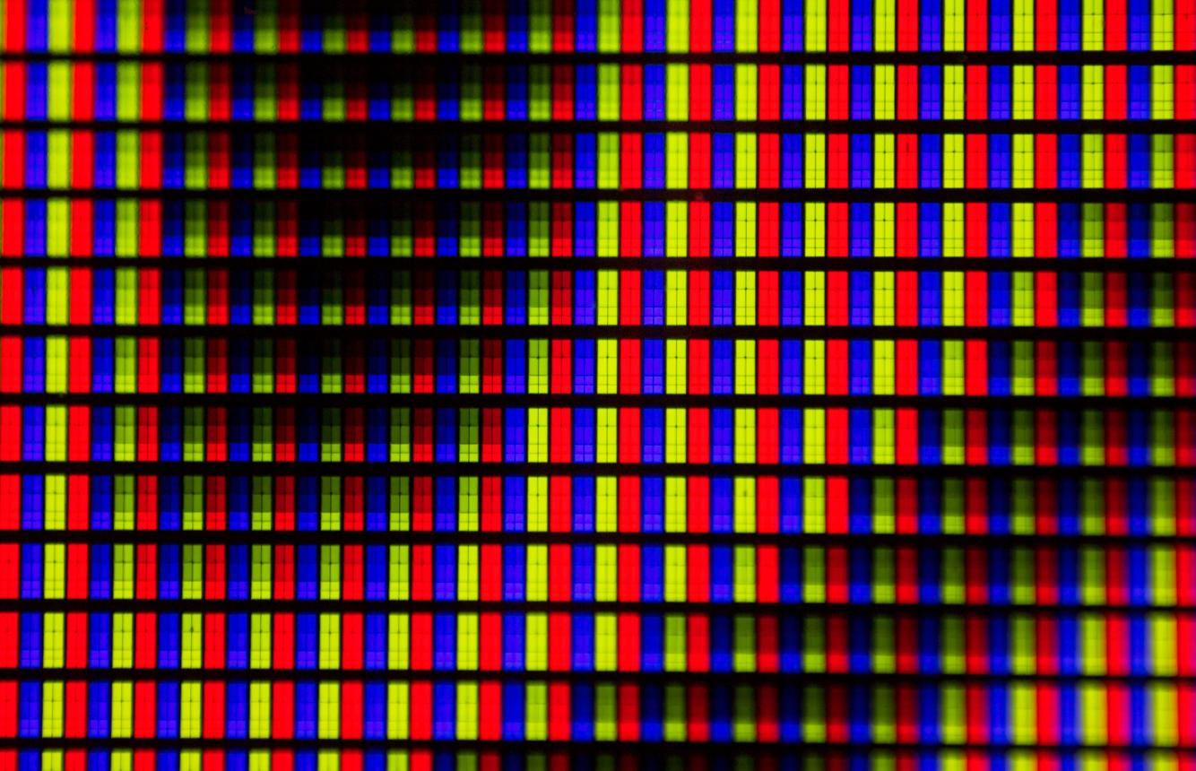

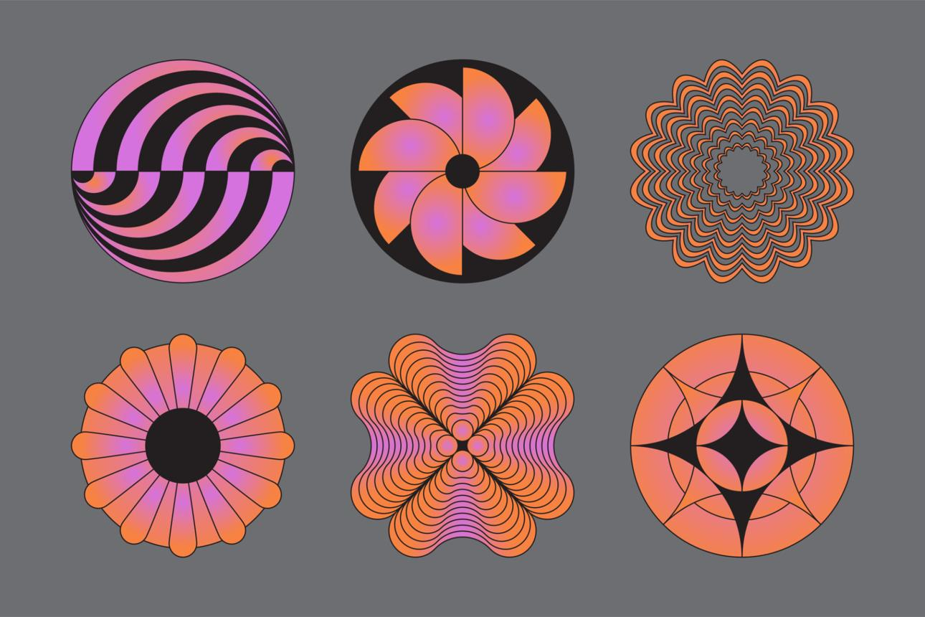

📸 1. Digital (Raster) Image
# Source: AI Source: Provided by: [Data Path: Persons Table -> ID Column: 1, Name_En Column: Motasem Essam] -> From: [ChatGPT] on [5/2/2026]
- Made of tiny squares called pixels
- Examples: photos, ScreenShot
- Quality depends on resolution

✏️ 2. Vector Image
# Source: AI Source: Provided by: [Data Path: Persons Table -> ID Column: 1, Name_En Column: Motasem Essam] -> From: [ChatGPT] on [5/2/2026]
- Made of lines, curves, and shapes
- Can be resized without losing quality
- Examples: logos, icons

🧠 Simple example
# Source: AI Source: Provided by: [Data Path: Persons Table -> ID Column: 1, Name_En Column: Motasem Essam] -> From: [ChatGPT] on [5/2/2026]
Think of:
- 📱 A photo on your phone → image
- 🖼️ A painting → image
- 🌐 A picture on a website → image

🎮 Image in computer graphics
# Source: AI Source: Provided by: [Data Path: Persons Table -> ID Column: 1, Name_En Column: Motasem Essam] -> From: [ChatGPT] on [5/2/2026]
Images are used to:
- Display pictures and visuals
- Create textures for 3D objects
- Show UI elements (icons, buttons)
- Represent final rendered scenes

⚙️ Key features
# Source: AI Source: Provided by: [Data Path: Persons Table -> ID Column: 1, Name_En Column: Motasem Essam] -> From: [ChatGPT] on [5/2/2026]
- 🖼️ Represents visual information
- 📊 Can be digital or drawn
- 🎨 Used in design, graphics, and media
- 💻 Displayed on screens or printed

🚀 In short:
# Source: AI Source: Provided by: [Data Path: Persons Table -> ID Column: 1, Name_En Column: Motasem Essam] -> From: [ChatGPT] on [5/2/2026]
Image = a visual picture or representation that shows information or objects to the viewer.

